Faculty of Computing

CS 212: Object Oriented Programming

Class: BESE-16A

Assignment 1:Fractals

Date: 21th February, 2025

Name:Muhammad Raffay Irfan

Assignment1: Fractals

There are 4 java class files.
One is main file where the program starts. It creates the Jframe and adds the sirpinski triangle Jpanel component to it. System is also told to use opengl as I am in ubuntu where it is not default. Jframe also gets focus. It is not resizable.
The Program when ran:
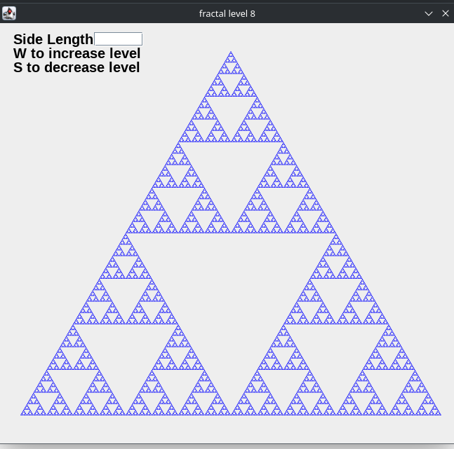

Then There is the sirpinski class where all proccesing is done. It extends Jpanel. There are two constructors one with no sidelength and one with it.
The fractal is drawn through the run method with given graphics2d component and point2d.Double for extra precision. It tries to reach till order 0 and create individual triangle if it doesn’t then it calculates the midpoint of sides of triangle using a private helper method called midpoint which calculates arithmetic mean of two pairs.
The base case ie order of the triangle can be get or set using getbasecase and setbasecase methods. They are made but aren’t used.
The Order of the triangle tells how many iterations to stop. This is controlled with a helper class called keyin which implements keylistener. If W or S key is pressed it calls increaseorder and decreaseorder methods of sirpinski class which changes the title also.
The paint component method is overridden. It creates graphics2d object which creates then the triangles using fill method to fill path2d. Antialiasing is also turned on which reduces noise on higher order but also increases render time by a magnitude.
Then there is default triangle which is done by getheight and getwidth methods of Jpanel class.It is aproxx 600 pixel side length.
Then there is triangle created by given side length. The default is 300 pixels. It is changed by a JTextField which is a component under Jpanel sirpinski created at the first constructor. textfield_sidelength does just that. It creates action performed listener when enter key is pressed on the field it changes side length to the entered text. If entered text is non numeric it throws error and triangle with default side length of 300 pixels is created. This triangle works the same as the default triangle on which we can change the order using W or S keys.
There is also mousein class which extends mouseAdapter binded to Jframe under sirpinski contructor using addmouselistener method. It is used to get focus from JTextField to Jframe when mouse button is pressed on the Jframe. The keyin which implements keylistener as told above is also binded to JFrame using addkeylistener under sirpinski constructor.
There is also text drawn to Jpanel using drawString in paintcomponent.
The Given java classes are attached in the src folder along with a demo video.

